Adapter 用于将我们的数据适配到视图上

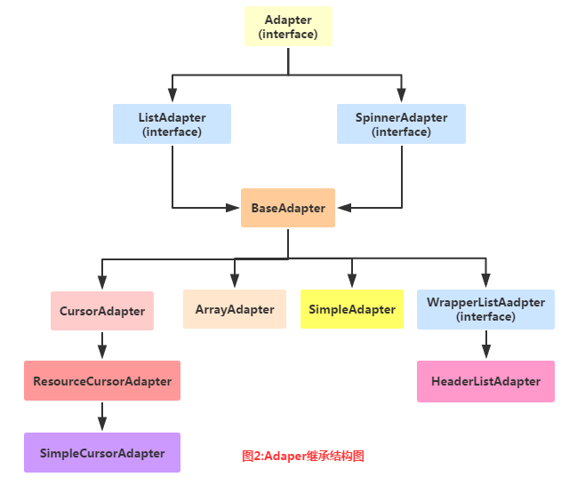

BaseAdapter：抽象类，实际开发中我们会继承这个类并且重写相关方法，用得最多的一个Adapter！

ArrayAdapter：支持泛型操作，最简单的一个Adapter，只能展现一行文字~

SimpleAdapter：同样具有良好扩展性的一个Adapter，可以自定义多种效果！

**简单示例**

**XML文件**

<ListView  
 android:id="@+id/list_test"  
 android:layout_height="match_parent"  
 android:layout_width="match_parent"/>

**Java**

protected void onCreate(Bundle savedInstanceState) {  
 super.onCreate(savedInstanceState);  
 setContentView(R.layout.*activity_main*);  
  
 //要显示的数据  
 String[] strs = {"基神","B神","翔神","曹神","J神"};  
 //创建ArrayAdapter  
 ArrayAdapter<String> adapter = new ArrayAdapter<String>  
 (this, android.R.layout.*simple_expandable_list_item_1*, strs);  
 //获取ListView对象，通过调用setAdapter方法为ListView设置Adapter设置适配器  
 ListView list_test = (ListView) findViewById(R.id.*list_test*);  
 list_test.setAdapter(adapter);  
}

**关于android.R.layout.simple_expandable_list_item_1**

android.R.layout.simple_expandable_list_item_1是系统提供的一个Layout

<?xml version="1.0" encoding="utf-8"?>  
  
<TextView xmlns:android="http://schemas.android.com/apk/res/android"  
 android:id="@android:id/text1"  
 android:layout_width="match_parent"  
 android:layout_height="?android:attr/listPreferredItemHeight"  
 android:paddingStart="?android:attr/expandableListPreferredItemPaddingLeft"  
 android:textAppearance="?android:attr/textAppearanceListItem"  
 android:gravity="center_vertical"  
 android:textAlignment="viewStart"  
/>

**SimpleAdapter示例**

**activity_main.xml**

<ListView  
 android:id="@+id/list_test"  
 android:layout_height="match_parent"  
 android:layout_width="match_parent"/>

**在layout目录新建list_item.xml**

<?xml version="1.0" encoding="utf-8"?>  
<LinearLayout xmlns:android="http://schemas.android.com/apk/res/android"  
 android:layout_width="match_parent"  
 android:layout_height="match_parent"  
 android:orientation="horizontal">  
  
 <!-- 定义一个用于显示头像的ImageView -->  
 <ImageView  
 android:id="@+id/imgtou"  
 android:layout_width="64dp"  
 android:layout_height="64dp"  
 android:baselineAlignBottom="true"  
 android:paddingLeft="8dp" />  
  
 <!-- 定义一个竖直方向的LinearLayout,把QQ呢称与说说的文本框设置出来 -->  
 <LinearLayout  
 android:layout_width="match_parent"  
 android:layout_height="wrap_content"  
 android:orientation="vertical">  
  
 <TextView  
 android:id="@+id/name"  
 android:layout_width="wrap_content"  
 android:layout_height="wrap_content"  
 android:paddingLeft="8dp"  
 android:textColor="#1D1D1C"  
 android:textSize="20sp" />  
  
 <TextView  
 android:id="@+id/says"  
 android:layout_width="wrap_content"  
 android:layout_height="wrap_content"  
 android:paddingLeft="8px"  
 android:textColor="#B4B4B9"  
 android:textSize="14sp" />  
  
 </LinearLayout>  
  
</LinearLayout>

主要关注其id

**MainActivity.java**

public class MainActivity extends AppCompatActivity {  
  
 private String[] names = new String[]{"B神", "基神", "曹神"};  
 private String[] says = new String[]{"无形被黑，最为致命", "大神好厉害~", "我将带头日狗~"};  
 private int[] imgIds = new int[]{R.mipmap.*ic_launcher*, R.mipmap.*ic_launcher*, R.mipmap.*ic_launcher*};  
  
 @Override  
 protected void onCreate(Bundle savedInstanceState) {  
 super.onCreate(savedInstanceState);  
 setContentView(R.layout.*activity_main*);  
  
 List<Map<String, Object>> listitem = new ArrayList<Map<String, Object>>();  
 for (int i = 0; i < names.length; i++) {  
 Map<String, Object> showitem = new HashMap<String, Object>();  
 showitem.put("touxiang", imgIds[i]);  
 showitem.put("name", names[i]);  
 showitem.put("says", says[i]);  
 listitem.add(showitem);  
 }  
  
 //创建一个simpleAdapter  
 SimpleAdapter myAdapter = new SimpleAdapter(getApplicationContext(), listitem, R.layout.*list_item*, new String[]{"touxiang", "name", "says"}, new int[]{R.id.*imgtou*, R.id.*name*, R.id.*says*});  
 ListView listView = (ListView) findViewById(R.id.*list_test*);  
 listView.setAdapter(myAdapter);  
 }  
}

**自定义BaseAdapter示例**

**新建Animal.java**

public class Animal {  
 private String aName;  
 private String aSpeak;  
 private int aIcon;  
  
 public Animal() {  
 }  
  
 public Animal(String aName, String aSpeak, int aIcon) {  
 this.aName = aName;  
 this.aSpeak = aSpeak;  
 this.aIcon = aIcon;  
 }  
  
 public String getaName() {  
 return aName;  
 }  
  
 public String getaSpeak() {  
 return aSpeak;  
 }  
  
 public int getaIcon() {  
 return aIcon;  
 }  
  
 public void setaName(String aName) {  
 this.aName = aName;  
 }  
  
 public void setaSpeak(String aSpeak) {  
 this.aSpeak = aSpeak;  
 }  
  
 public void setaIcon(int aIcon) {  
 this.aIcon = aIcon;  
 }  
}

**新建AnimalAdapter.java**

package com.example.myapplication;  
  
import android.content.Context;  
import android.view.LayoutInflater;  
import android.view.View;  
import android.view.ViewGroup;  
import android.widget.BaseAdapter;  
import android.widget.ImageView;  
import android.widget.TextView;  
  
import java.util.LinkedList;  
  
public class AnimalAdapter extends BaseAdapter {  
  
 private LinkedList<Animal> mData;  
 private Context mContext;  
  
 public AnimalAdapter(LinkedList<Animal> mData, Context mContext) {  
 this.mData = mData;  
 this.mContext = mContext;  
 }  
  
 @Override  
 public int getCount() {  
 return mData.size();  
 }  
  
 @Override  
 public Object getItem(int position) {  
 return null;  
 }  
  
 @Override  
 public long getItemId(int position) {  
 return position;  
 }  
  
 @Override  
 public View getView(int position, View convertView, ViewGroup parent) {  
 // 使用 R.layout.list_item 生成 View，并将生成的 View 插入到 parent 中  
 View listItem = LayoutInflater.*from*(mContext).inflate(R.layout.*list_item*,parent,false);  
 ImageView img_icon = (ImageView) listItem.findViewById(R.id.*imgtou*);  
 TextView txt_aName = (TextView) listItem.findViewById(R.id.*name*);  
 TextView txt_aSpeak = (TextView) listItem.findViewById(R.id.*says*);  
  
 // 设置生成 View 的属性值  
 img_icon.setBackgroundResource(mData.get(position).getaIcon());  
 txt_aName.setText(mData.get(position).getaName());  
 txt_aSpeak.setText(mData.get(position).getaSpeak());  
 return listItem;  
 }  
}

**在layout目录新建list_item.xml**

<?xml version="1.0" encoding="utf-8"?>  
<LinearLayout xmlns:android="http://schemas.android.com/apk/res/android"  
 android:layout_width="match_parent"  
 android:layout_height="match_parent"  
 android:orientation="horizontal">  
  
 <!-- 定义一个用于显示头像的ImageView -->  
 <ImageView  
 android:id="@+id/imgtou"  
 android:layout_width="64dp"  
 android:layout_height="64dp"  
 android:baselineAlignBottom="true"  
 android:paddingLeft="8dp" />  
  
 <!-- 定义一个竖直方向的LinearLayout,把QQ呢称与说说的文本框设置出来 -->  
 <LinearLayout  
 android:layout_width="match_parent"  
 android:layout_height="wrap_content"  
 android:orientation="vertical">  
  
 <TextView  
 android:id="@+id/name"  
 android:layout_width="wrap_content"  
 android:layout_height="wrap_content"  
 android:paddingLeft="8dp"  
 android:textColor="#1D1D1C"  
 android:textSize="20sp" />  
  
 <TextView  
 android:id="@+id/says"  
 android:layout_width="wrap_content"  
 android:layout_height="wrap_content"  
 android:paddingLeft="8px"  
 android:textColor="#B4B4B9"  
 android:textSize="14sp" />  
  
 </LinearLayout>  
  
</LinearLayout>

**MainActivity.java 文件**

public class MainActivity extends AppCompatActivity {  
  
 private List<Animal> mData = null;  
 private AnimalAdapter mAdapter = null;  
 private ListView list_animal;  
  
 @Override  
 protected void onCreate(Bundle savedInstanceState) {  
 super.onCreate(savedInstanceState);  
 setContentView(R.layout.*activity_main*);  
 list_animal = (ListView) findViewById(R.id.*list_test*);  
 mData = new LinkedList<Animal>();  
 mData.add(new Animal("狗说", "你是狗么?", R.mipmap.*ic_launcher*));  
 mData.add(new Animal("牛说", "你是牛么?", R.mipmap.*ic_launcher*));  
 mData.add(new Animal("鸭说", "你是鸭么?", R.mipmap.*ic_launcher*));  
 mData.add(new Animal("鱼说", "你是鱼么?", R.mipmap.*ic_launcher*));  
 mData.add(new Animal("马说", "你是马么?", R.mipmap.*ic_launcher*));  
 mAdapter = new AnimalAdapter((LinkedList<Animal>) mData, this);  
 list_animal.setAdapter(mAdapter);  
 }  
  
}

